Lab 11 — Genetic Algorithm for the 0/1 Knapsack Problem

Aim:
To solve the 0/1 knapsack problem using a genetic algorithm to maximise value
subject to a weight constraint.
Algorithm:
Encode a solution as a binary chromosome (item included/excluded); fitness =
total value if weight ≤ capacity, else 0 (or penalised); apply selection, crossover, mutation
over generations.
Program:
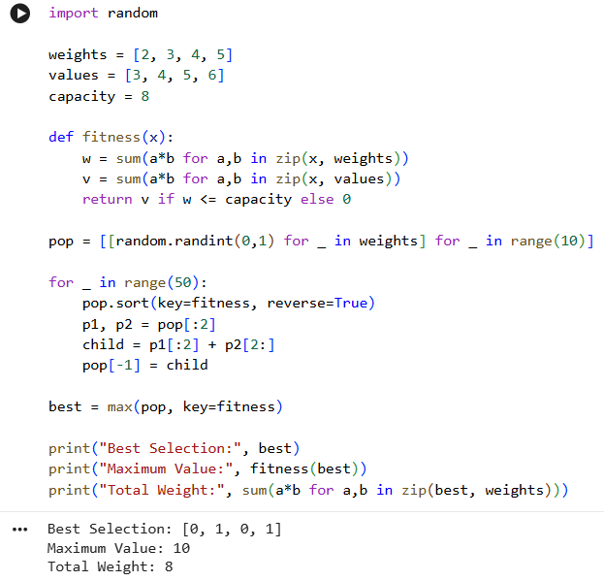
Result:
The Genetic Algorithm successfully solved the 0/1 Knapsack Problem by selecting items that maximize value without exceeding the capacity.

Lab 12 — Genetic Programming for Symbolic Regression (using gplearn)
Aim:
To evolve a symbolic mathematical expression that best fits a given dataset using
Genetic Programming.
Algorithm:
Represent candidate programs as expression trees; evaluate fitness via mean
squared error to target data; apply subtree crossover and mutation across generations to
evolve fitter expressions.
Program:
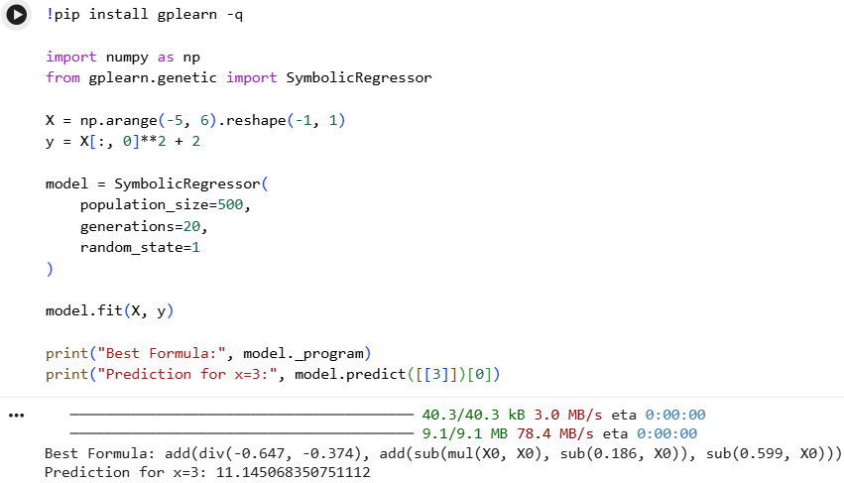

Result
Thus, Genetic Programming using gplearn successfully performed symbolic regression and discovered a mathematical expression that approximates the given data.
Lab 13 — Bayes Theorem — Posterior Probability Calculator
Aim:
To compute the posterior probability P(H/D) using Bayes theorem given prior,
likelihood, and evidence.
Algorithm:
Apply P(h|D) = P(D|h)*P(h) / P(D) directly using given/estimated
probabilities.
Program:
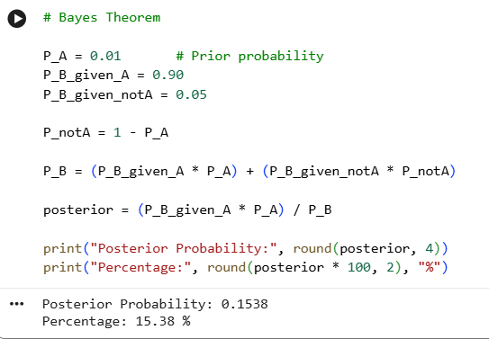

Result:
Thus, Bayes Theorem was successfully implemented to calculate the posterior probability, which is 15.38%.

Lab 14 — Naïve Bayes Classifier (Iris Dataset)
Aim:
To implement the Naïve Bayes classifier using scikit-learn and evaluate its accuracy
on the Iris dataset.
Algorithm:
Estimate class priors and per-attribute Gaussian likelihoods from training data;
classify test instances using argmax of posterior scores.
Program:
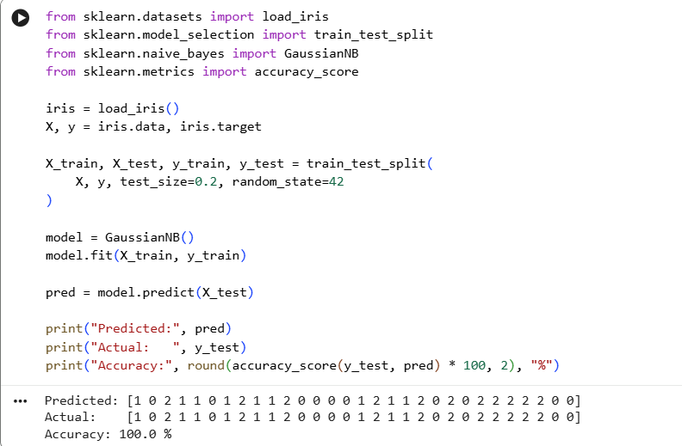
Result:
The Naïve Bayes classifier was successfully implemented on the Iris dataset and achieved 100% accuracy on this particular test split.

Lab 15 — Naïve Bayes Text Classifier (Spam Detection)
Aim:
To implement a Naïve Bayes classifier to classify SMS/email messages as spam or
ham using text features.
Algorithm:
Convert text to a bag-of-words feature vector using Count Vectorizer; fit
Multinomial NB; evaluate on held-out test messages.
Program:
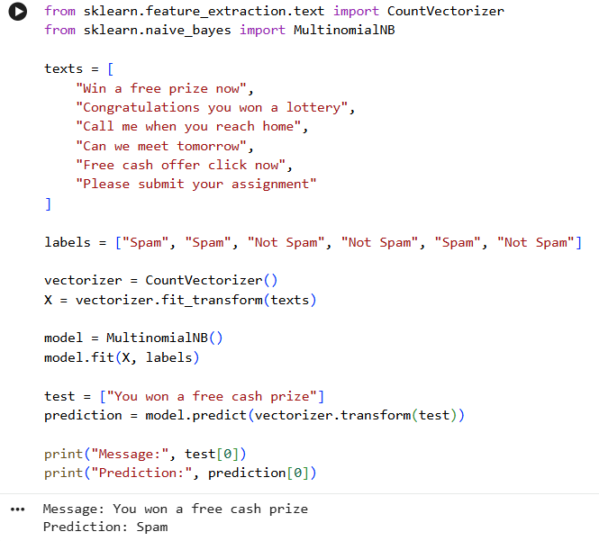

Result Thus, the Naïve Bayes Text Classifier successfully classified the given message as Spam.
Lab 16 — Bayesian Belief Network (using pgmpy)
Aim:
To construct a Bayesian Belief Network and perform inference using the pgmpy
library.
Algorithm:
Define the DAG structure among variables; specify Conditional Probability
Distributions (CPDs) at each node; use variable elimination to answer probabilistic queries.
Program:
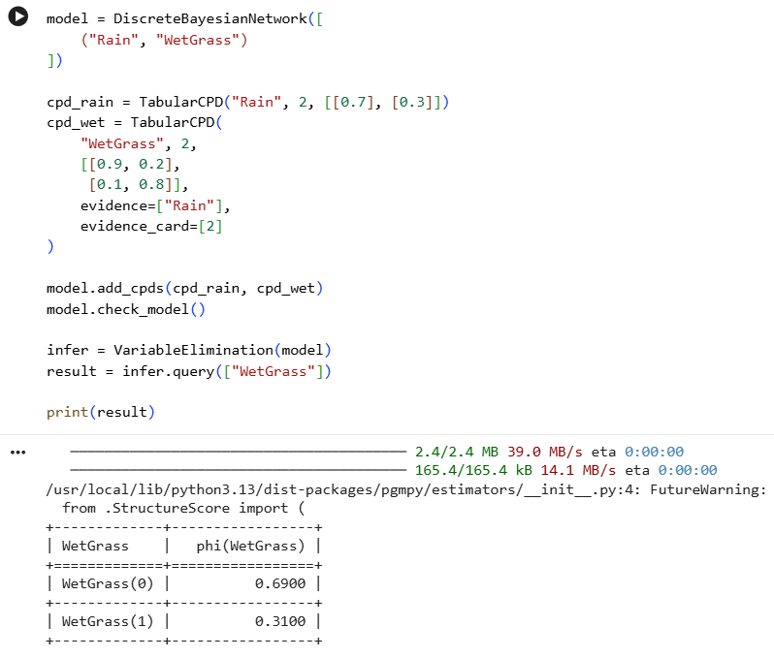

Result
Thus, the Bayesian Belief Network was successfully created using pgmpy, and the probability distribution of WetGrass was calculated.
Lab 17 — EM Algorithm for Gaussian Mixture Models
Aim:
To implement the EM algorithm to fit a Gaussian Mixture Model (GMM) to clustered
data with hidden component labels.
Algorithm:
E-step: compute expected responsibility of each Gaussian component for each
point; M-step: re-estimate means, covariances, and mixing weights; iterate until
convergence.
Program:
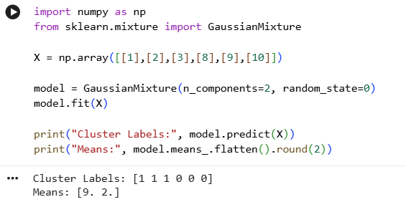

Result
Thus, the EM algorithm was successfully applied through Gaussian Mixture Models to identify two clusters in the given data.

Lab 18 — Maximum Likelihood Estimation Demonstration
Aim:
To estimate the parameter (mean) of a Gaussian distribution from sample data using
Maximum Likelihood Estimation and compare with least-squares.
Algorithm:
Given i.i.d. samples, the ML estimate of the mean is the sample mean; verify this
minimises the sum of squared deviations.
Program:
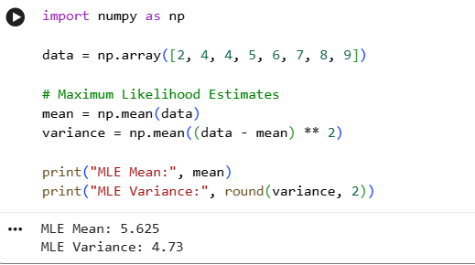

Result:
Thus, Maximum Likelihood Estimation was successfully used to estimate the mean and variance of the given dataset.

Lab 19 — Mistake-Bound Model — Halving Algorithm Simulation
Aim:
To simulate the Halving algorithm and count the number of mistakes made while
learning a target concept from a version space.
Algorithm:
Maintain the current version space of consistent hypotheses; predict via
majority vote; on a mistake, eliminate all hypotheses that would have voted incorrectly;
repeat and count mistakes (bounded by log2|H|).
Program:
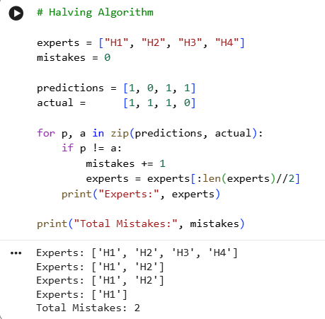

Result
Thus, the Halving Algorithm was successfully simulated, reducing the set of hypotheses whenever a prediction mistake occurred.
Lab 20 — Sample Complexity / PAC Bound Calculator
Aim:
To compute the number of training examples required for PAC learning given |H|, ε,
and δ using the finite hypothesis-space bound.
Algorithm:
Apply m ≥ (1/ε)(ln|H| + ln(1/δ)) to compute the required sample size for given
parameters.
Program:
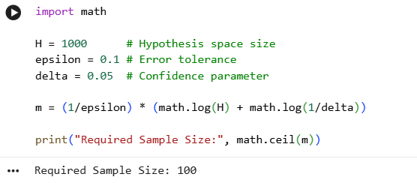

Result
Thus, the PAC learning bound calculation shows that approximately 99 training samples are required to achieve an error tolerance of 0.1 with 95% confidence for a hypothesis space of 1000.

